**Project Report Template**

**Introduction:**

**1.1Overview:**

Infographics have been around for many years and recently the increase of the number of easy-to-use, free tools have made the creation of infographics available to a large segment of the population. Social media sites such as [Facebook](https://en.wikipedia.org/wiki/Facebook" \o "Facebook) and [Twitter](https://en.wikipedia.org/wiki/Twitter) have also allowed for individual infographics to be spread among many people around the world. Infographics are widely used in the age of short [attention span](https://en.wikipedia.org/wiki/Attention_span).

**1.2 Purpose:**

They can tell a story that captivates readers in a way words alone fail to accomplish.

**2. PROBLEM DEFINITION & DESIGNING THINKING:**

**2.1. Empathy Map :**

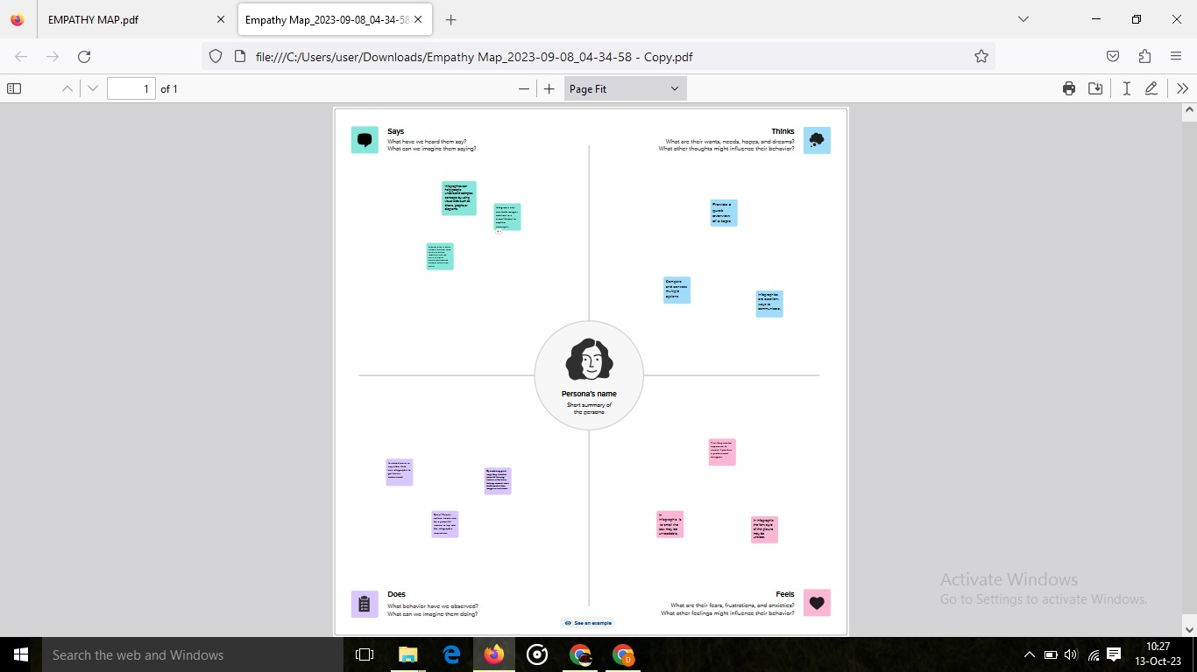

**2.2. Ideation & Brainstorming:**

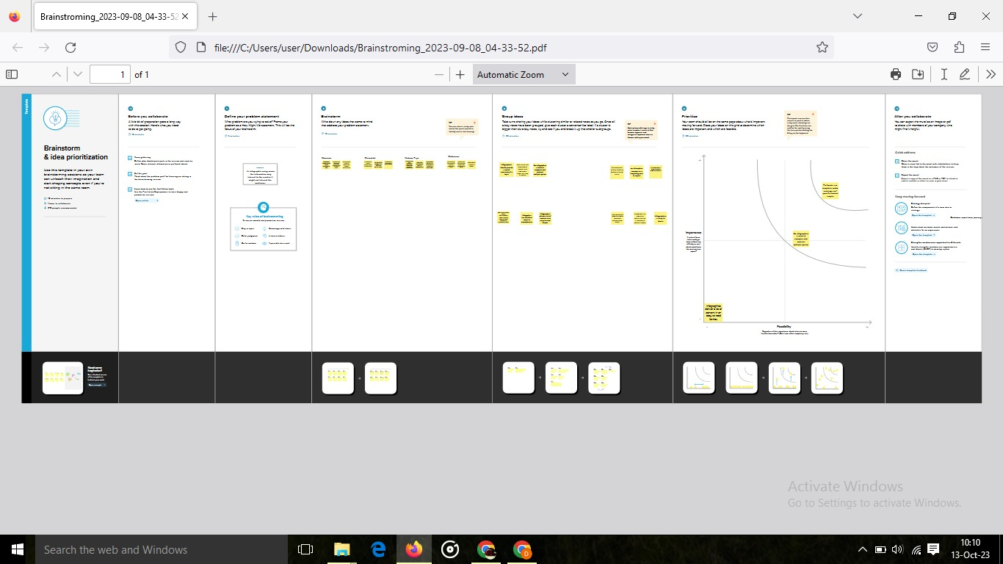

**3.Result:**

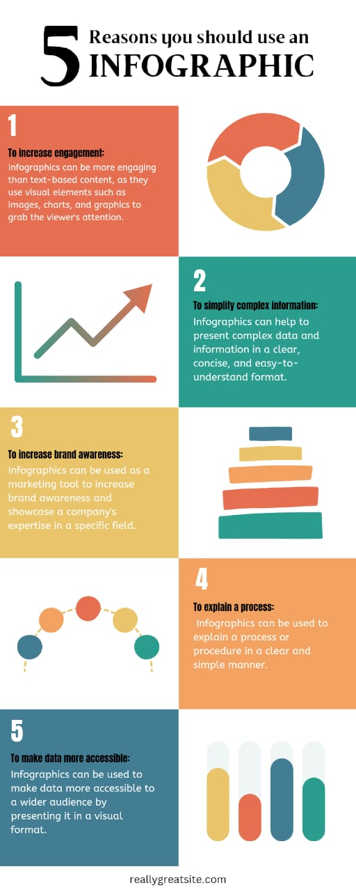

**4. Advantages and Disadvantages:**

* **Easy to understand** (Pros): Infographics can make it easier to access the key points of your material in a way that is easy to consume. Time-consuming to create (Cons): To make the infographic engaging, you need to create a format that is simple to read, includes relevant pictures, and conveys information.
* One disadvantage of infographics is the **high amount of time required for preparation**. The design alone is very complicated, and then there is the actual graphical work. Another problem is that infographics often come out as being textless. This is because Google is unable to read the text contained in the graphics.

**5. APPLICATION:**

An infographic (information graphic) is a representation of information in a graphic format designed **to make the data easily understandable at a glance**.

**6.CONCLUSION:**

**Infographics guide your audience towards a particular conclusion**, while data visualization presents all the information and allows your audience to come to their own conclusions. This is the biggest difference between these two visual elements.